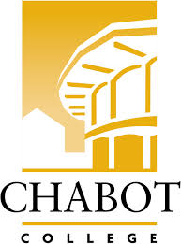**Career Education (CE Committee)**

Chabot College – Zoom

Monday, February 10, 2025

12:00-1:00

**AGENDA**

1. Welcome & Land acknowledgement – Robin
2. Announcements
   1. Professional Development – Out of State Travel
   2. Career Widget – ATB Pilot
   3. Navigating AI Together: A Community College Unconference – 3/7
   4. Career Open House – Foundation Request
3. Handshake Presentation- John
4. CE Events
   1. ROP Careers in Healthcare Day – 3/7
   2. CE Open House – 3/22
   3. SOAR Day – 4/19
   4. ECD Job Fair – 4/29
   5. ROP Digital Media Day – 5/2
   6. Ambulance Meet & Greet Day – 5/23
5. CE Website/Newsletter
6. Future Topics
7. Good of the Order - Kristina
8. Next Meeting 2/24/2025
9. Adjournment

**Mission Statement**

*Chabot College is a dynamic, student-centered community college that serves the educational, career, job skill, and personal development needs of our community. We provide culturally responsive, revitalizing, and sustaining learning and support services driven by a goal of equity. Building upon students’ strengths and voices, we empower students to achieve their goals and lead us towards an equitable and sustainable world.*